**Lab Number: 08 Date: 2025/08/17**

# Title: Creating VLAN and VLAN Trunking using Packet Tracer

# Theory:

1. **VLAN, VLAN Trunking & its Architecture**

A VLAN (Virtual Local Area Network) is a network configuration that segments a single physical network into multiple logical networks. Each VLAN acts like an independent network, even though multiple VLANs may share the same physical network infrastructure. VLANs improve network security, reduce broadcast traffic, and allow network administrators to segment traffic logically based on factors like department or function within an organization.

**VLAN Trunking:**

VLAN trunking is a method used to allow traffic from multiple VLANs to traverse a single network link between switches or other network devices. This is achieved by tagging Ethernet frames with a VLAN identifier, commonly through IEEE 802.1Q tagging. Trunking enables the extension of VLANs across network devices, supporting greater flexibility in network design and allowing VLANs to span across different physical locations.

**VLAN Architecture:**

VLAN architecture is designed to logically group devices across different network segments, creating multiple broadcast domains on a single network infrastructure. Each VLAN typically corresponds to a different logical network, isolating traffic between VLANs unless explicitly allowed through routing or firewall rules. The architecture includes components like access ports (where devices are connected to architecture includes components like access ports (where devices are connected to the VLAN), trunk ports (which carry traffic for multiple VLANs), and VLAN-aware network devices that manage traffic across various segments. This modular design enhances scalability, security, and performance in modern networks.

1. **Components Used**

**Hardware:** Switches (2), Ethernet cables, End devices (4).

**Software:** Cisco Packet Tracer

1. **Network Diagram**

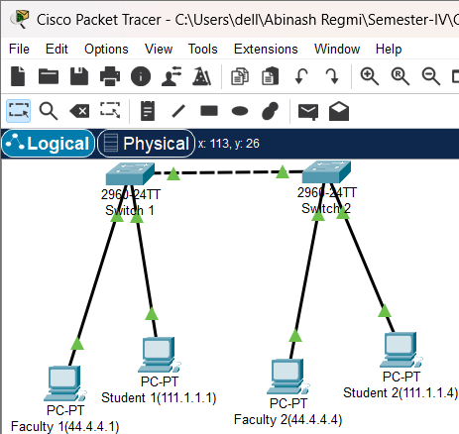

Fig: Network map for VLAN

**Procedure**

Here is the procedure for creating the LAN network shown in the image using Cisco Packet Tracer:

**Step 1: Launch Cisco Packet Tracer**

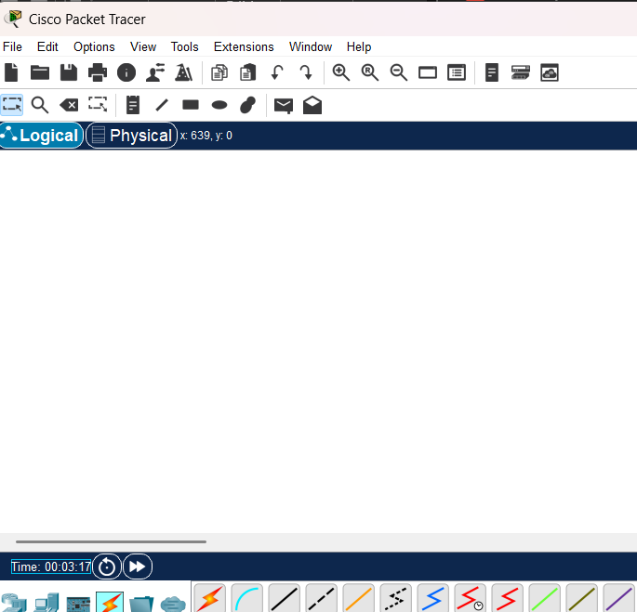

Fig: Workspace for network design

**Step 2: Add the network devices to the workspace and connecting devices:**

2.1 From the Device-Type Selection box, choose the following devices and add them to the workspace:

2.2 One 2690-24TT Switch and four PC’s

2.3 Use the copper straight-through cable to connect each PC to one of the available ports on the switch.

2.4 Ensure that each connection is made properly.



Fig: Connection between all devices in VLAN

**Step 4: Configure IP addresses:**

4.1 Right-click on each PC and select “IP Configuration”.

4.2 In the IP Configuration window, enter the IP address as 44.4.4.1 for port 1 and 111.1.1.1 for port 2 in switch 1 and 44.4.4.4 for port 1 and 111.1.1.4 for port 2 in switch 2, subnet mask, and default gateway for each PC.

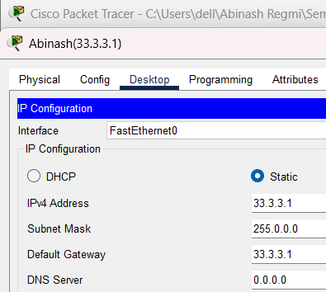

fig: IP configuration

**Step 5: Configuring VLANs:**

5.1 Create VLAN on both Switches & Assign Port to both switches.

5.2 Create truncation in the both switches

**Code for VLAN configurations:**

Switch(config)#vlan 10

Switch(config-vlan)#name student

Switch(config-vlan)#vlan 20

Switch(config-vlan)#name faculty

Switch(config-vlan)#exit

Switch(config)#exit

**Code for Assigning ports:**

Switch#config t

Switch(config)#int fac 0/3

Switch(config-if)#switchport mode access

Switch(config-if)#switchport access vlan 10

Switch(config-if)#int fa 0/2

Switch(config-if)#switchport mode access

Switch(config-if)#switchport access vlan 20

Switch(config-if)#exit

Switch(config)#exit

**Code for Trunking Switches:**

Switch#config t

Switch(config)#int fa 0/3

Switch(config-if)#switchport mode trunk

Switch(config-if)#exit

 Switch(config)#exit

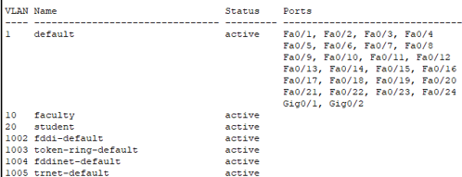

Fig: Assigning ports to VLAN

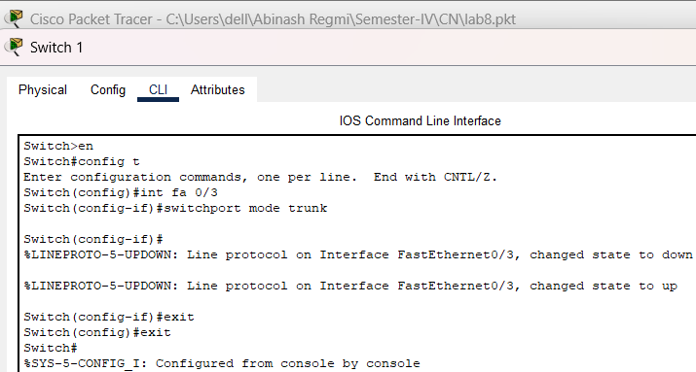

Fig: Configuring trunking between switches

**Step 7: Verify connectivity**

7.1 To test whether the network is working, you can ping other devices on the network from each PC.

7.2 To ping another device, open a command prompt on the PC and type “ping <IP address of the other device>”.

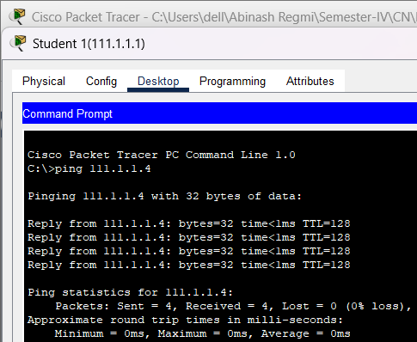 7.3 If the ping is successful, you should see replies from the other device.

Fig: Connectivity test between network student1(111.1.1.1) and (111.1.1.4)

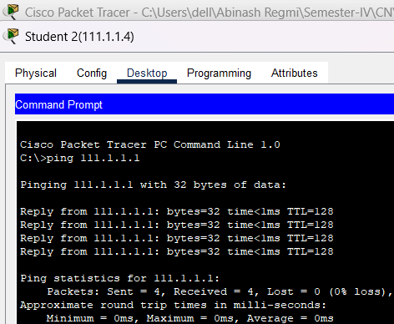

Fig: Connectivity test between network student1(111.1.1.4) and (111.1.1.1)

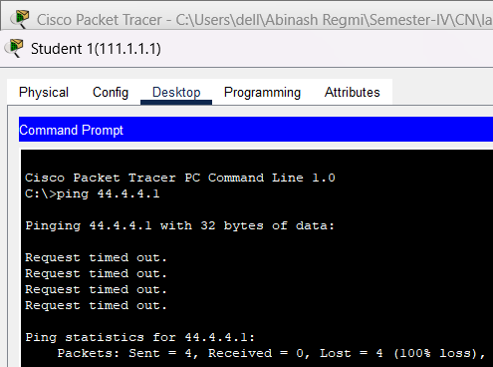

Fig: Connectivity test between network student1(111.1.1.1) and faculty1(44.4.4.1)

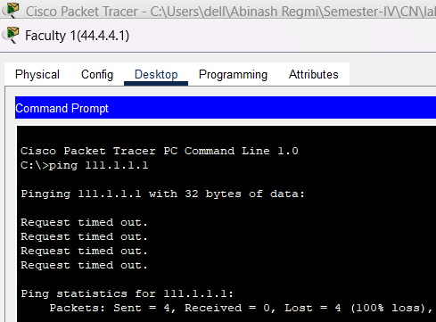

Fig: Connectivity test between network faculty1(44.4.4.1)) and student1(111.1.1.1)

**Conclusion**

In conclusion, creating VLANs and implementing VLAN trunking using Cisco

Packet Tracer enhances network segmentation and management. By keeping devices into distinct VLANs, you effectively reduce broadcast domains, improve security, and optimize network performance. VLAN trunking, which facilitates the transmission of multiple VLANs across a single link, ensures efficient communication between VLANs across switches. This approach highlights the importance of structured network design in reducing broadcasting and simplifying network administration, ultimately contributing to scalability and efficiency of modem networks.